**OverTheWire Bandit - Level 1 to Level 2 Writeup**

**Introduction**: This writeup documents my experience solving Levels 1 to 2 of the OverTheWire Bandit challenge, a CTF-style game focused on learning about security concepts.

**Author**: Misha Jain

**Date**: October 19, 2023

**Tools Used:**

Terminal (SSH client)

**Challenge Description:**

Level 1 to Level 2 of Bandit involves connecting to a remote server via SSH and retrieving the password located in the home directory of the server.

**Enumeration:**

For Level 1, we need to connect to the server using the credentials we obtained in Level 0. This will reveal a password for Level 2.

**Exploitation - Level 1:**

To connect to the server for Level 1 using SSH, we use the provided credentials:

ssh bandit1@bandit.labs.overthewire.org -p 2220

Use the password obtained from Level 0, which is NH2SXQwcBdpmTEzi3bvBHMM9H66vVXjL to gain access.

**Password Retrieval - Level 1:**

The password for Level 2 is stored in a file named ‘-’ in the home directory. We can use the cat command to read the contents of this file:

cat ./-

To display a file named ‘-’, we use the cat command along with the ‘./’ prefix to specify the current directory and explicitly mention the filename. By using ‘./’ as the argument to cat, you are indicating to the shell that you want to read the file named ‘-’ in the current directory, rather than interpreting it as a special character. This allows you to correctly display the contents of the file named ‘-‘.

This command will display the Level 2 password.

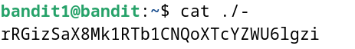

**Password – Level 2:**

The password for Level 2 is: rRGizSaX8Mk1RTb1CNQoXTcYZWU6lgzi

**Exploitation – Level 2:**

Now that we have the Level 2 password, we can connect to the server for Level 2 using SSH:

ssh bandit2@bandit.labs.overthewire.org -p 2220

Use the Level 2 password to gain access.

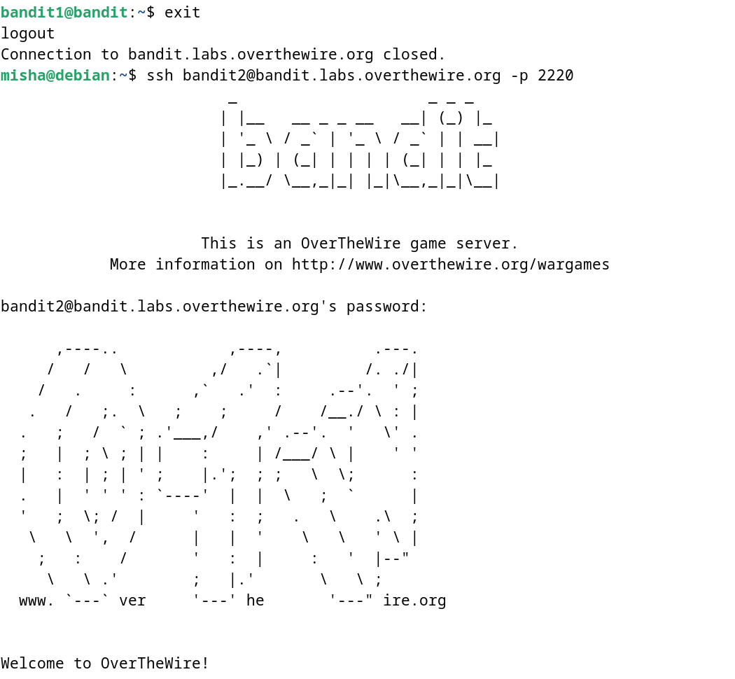

**Lessons Learned:** Level 1 to 2 introduced us to reading the contents of a file with a special character as a name using the cat command.

**Conclusion:**

Levels 1 to 2 of the OverTheWire Bandit challenge continue to build on basic Linux command-line skills while introducing new challenges. These levels are suitable for beginners to learn more about shell commands and basic file manipulation.